

YEAR 11 ATAR HUMAN BIOLOGY

Task 8: Body Systems II

Test

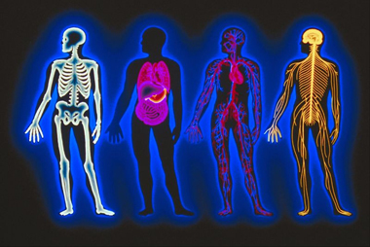

-DO NOT MARK THIS BOOKLET-

Multiple Choice: 20 marks

Short Answer: 20 marks

**TOTAL 40 MARKS**

**Section A: Multiple Choice (20 Marks)**

Answer all questions by placing and X through the most correct answer on the multiple choice answer sheet.

1. The vertebral column, rib cage and skull form the:

(a) axial skeleton.

(b) pectoral girdle.

(c) appendicular skeleton.

(d) pelvic girdle.

1. The type of joint illustrated by the head on the spinal column [atlas] is a:

(a) ball and socket.

(b) hinge.

(c) pivot.

(d) partially moveable.

1. The tissue that gives shape to the external ear, the tip of the nose, and the walls of the trachea is:

(a) soft bone.

(b) adipose tissue.

(c) cartilage.

(d) smooth muscle.

1. The bones of the lower limb do **NOT** include the:

(a) metatarsals.

(b) tibia.

(c) scapula.

1. fibula.

Diagram below refers to questions 5 and 6



1. Which of the above is a hinge joint ?

(a) A.

(b) B.

(c) C.

(d) D.

1. Which one of the following pairs of movements is possible at the joint named **E**?

(a) flexion and abduction.

(b) extension and rotation.

(c) extension and adduction.

(d) flexion and extension.

1. The shaft of a long bone is called the:

(a) epiphysis.

(b) diaphysis.

(c) periosteum.

(d) central column.

1. The function of synovial fluid is to:

(a) maintain strong ligaments.

(b) allow friction-free movement in joints.

(c) provide added strength to joints.

1. lubricate the tendons.
2. The major mineral elements deposited in bone are:

(a) magnesium and calcium.

(b) phosphorous and calcium.

(c) phosphorous and magnesium.

1. phosphorous, magnesium and calcium
2. Contraction of which one of the following muscles will cause a straightened arm to bend ?

(a) Triceps.

(b) Extensors.

(c) Biceps.

(d) Quadriceps.

The next two questions refer to the following diagram

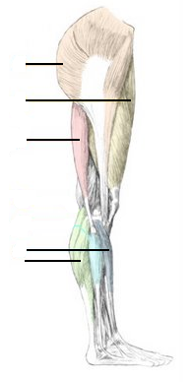

**A**

**B**

**C**

**D**

**E**

11). Two antagonistic muscles are:

(a) C and D

(b) A and C

(c) B and E

(d) B and C

12). The muscles which would raise the toes off the ground would be:

(a) B

(b) C

(c) D

(d) E

Refer to the diagram opposite

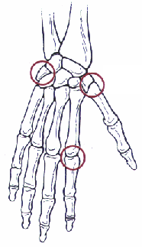

**A**

13). The joint labelled A

(a) Saddle joint

(b) Hinge Joint

(c) Condyloid

(d) Gliding joint

14). Place the words in the correct order to show the muscle structure from large structures to smallest structures.

(a) actin, myosin, myofibrils, muscle fibres, skeletal muscle

(b) skeletal muscle, muscle fibres, myofibrils, actin, myosin

(c) myofibrils, actin, myosin, muscle fibres, skeletal muscle

(d) skeletal muscle, myofibrils, muscle fibres, actin, myosin

15). Which of the following pairings is correct?

(a) Hip - Ball and socket.

(b) Thumb - Pivot.

(c) Elbow - Gliding.

(d) Wrist - Hinge.

16).

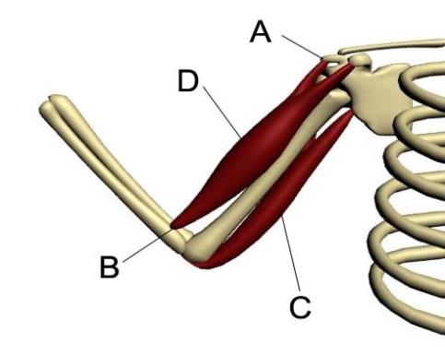

Source picture created by Clinton Ellard

The correct names for the labels A, D, C and B from the top in the picture above show:

a) biceps, triceps, insertion, origin

b) origin, biceps, triceps, insertion,

c) triceps, biceps insertion, origin

d) insertion, triceps, biceps , origin

*The next question refers to the diagram of a model of a joint. The arrows indicate the movement it permits:*



17). This is an example of a

a) sliding joint such as between the vertebrae.

b) pivot joint such as between the atlas and axis vertebrae.

c) gliding joint such as in the wrist.

d) saddle joint such as in the thumb.

18). Spongy bone

a) contains osteons running in a transverse direction in the bone.

b) contains red bone marrow where blood cells are formed.

c) is soft and spongy

d) is a storage centre for fat.

*The next question refers to the diagram of the cross section of compact bone below:*



19). In the diagram above,

a) the rings indicated by structure A store sodium and calcium.

b) osteocytes would be found in structure B.

c) structure C is the lacunae.

d) structure D contains yellow marrow.

**20).** The connections between muscles and bones are:

a) Tendons

b) Ligaments

c) Cartilage

d) Adipose tissue

**PART B: Short Answer Section (20 marks)**

**Question 66**

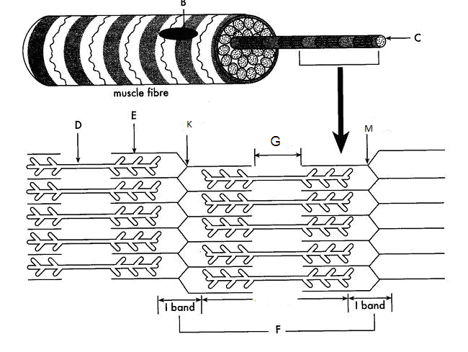

Part (a) of the question refers to the diagram above.

(a) The diagram represents the sliding filament model of muscle contraction. A sarcomere in a skeletal muscle is shown in the relaxed position.

(i) Identify the proteins labelled as D and E in the diagram. (2 marks)

D ________________________________________________

E _________________________________________________

(ii) In the box below, accurately draw the same sarcomere as it would appear when the muscle is contracted. (2 marks)

(iii) Explain what has happened to cause the change you have shown in the diagram between the relaxed and contracted positions of the sarcomere. (2 marks)

________________________________________________________________________________________________________________________________________________________________________________________________________________________________________________________________________________________________________________________________________________________________________________________________________________________________________________________________________

(b) Apart from skeletal muscle, there are two other muscle types in the human body.

Name one other muscle type and state one way in which the structure of this type of muscle differs from skeletal muscle. (2 marks)

____________________________________________________________________________________________________________________________________________________________________________________________________________________________________

____________________________________________________________________________________________________________________________________________________________________________________________________________________________________

**Total: 8 marks**

**Question 17** refers to the diagram below

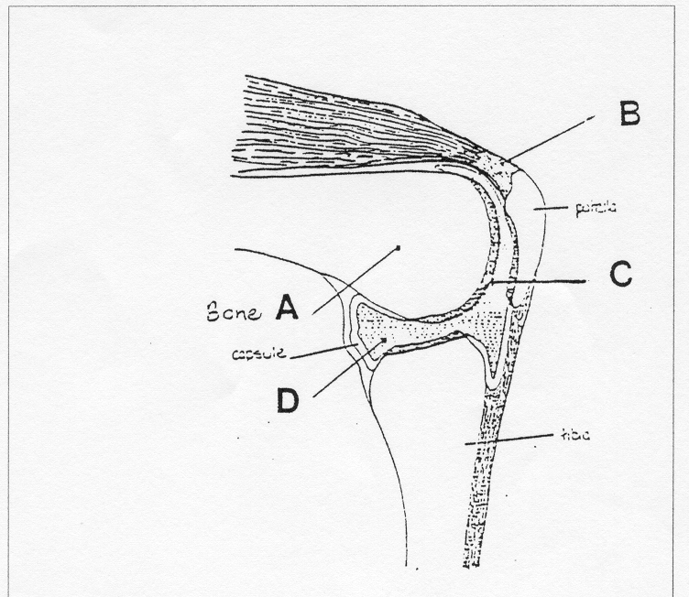

Label the structures A,B,C and D in the spaces provided below.

#### A ____________________________ C_____________________________

#### B ____________________________ D_____________________________

(4 marks)

b. The type of joint illustrated above is a synovial hinge joint. Name two **other** types of synovial joints and give an example of where they are found.

i)_______________________________________________________________

ii)_______________________________________________________________

(2 marks)

1. Name the muscle that must contract to straighten the leg. Is this an example of

extension or flexion? (2 marks)

_____________________________________________________________________________________________________________________________________________________________________________________________________________________

**Total: 8 marks**

Question 18 (4 marks)

Label the following diagram of the skeleton with the correct names for each of the bones.

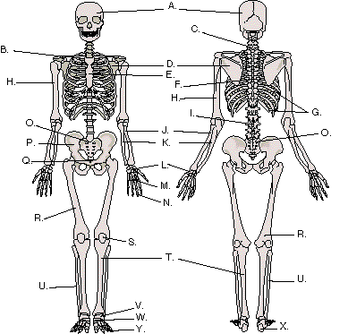

N __________________________________________

U __________________________________________

W __________________________________________

J __________________________________________



**YEAR 11 ATAR HUMAN BIOLOGY**

Task 8: Body Systems II

Test

SCORES:

MC: /20

SA: /20

TOTAL: /40

_______ %

**NAME:_____________________________**

**TEACHER:__________________________**

**DATE:______________________________**

**Section A: Multiple choice (15 Marks)**

Answer all questions by circling the most correct answer on the multiple choice answer sheet.

1. a b c d 13. a b c d

2. a b c d 14. a b c d

3. a b c d 15. a b c d

4. a b c d 16. a b c d

5. a b c d 17. a b c d

6. a b c d 18. a b c d

7. a b c d 19. a b c d

8. a b c d 20. a b c d

9. a b c d 21. a b c d

10. a b c d 22. a b c d

11. a b c d 23. a b c d

12. a b c d 24. a b c d

25. a b c d